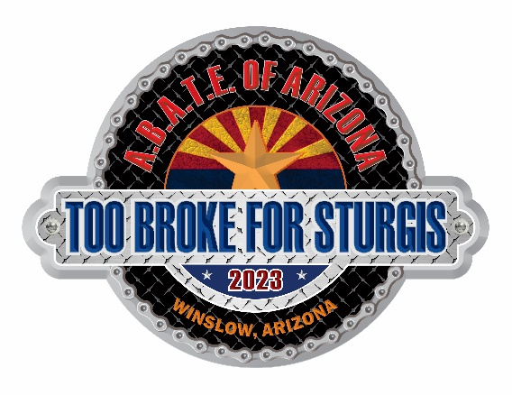



**VENDOR FAQs**



THANK YOU for your participation at TBFS. Your support this year, and year-after-year, helps ABATE and the TBFS Committee achieve its goal of offering a wide variety of goods, services, apparel, and food to meet the needs of the TBFS participants.

**Points of Contact**

* Event Coordinator: Sandra Tavares (858) 414-2392

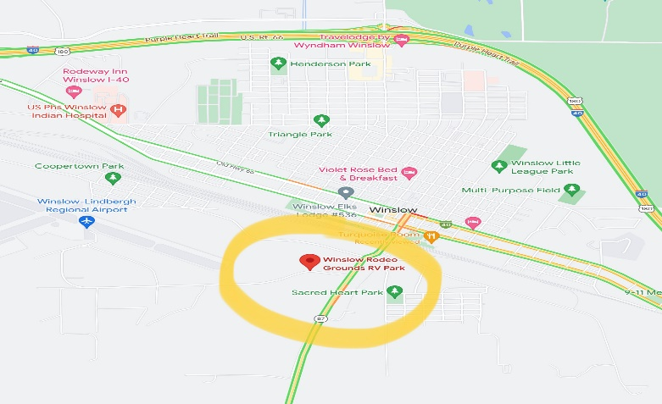

**Location of TBFS (@Winslow rodeo grounds)**

Address is 502 Airport Rd.

Its just behind the Airport, Google maps finds it but other maps don’t, you can also use Maps and type In Red Sands School, that will take you there.

**Weather**

While weather is outside of our control, Anticipate 80 – 90 degrees during the day and 60 – 70 degrees at night.

**Camping**

The dry camping area at TBFS is plentiful, first come – first serve. Tents are no charge, RVs/trailers add $30 for the entire weekend). Also available are port-o-johns, hand washing stations.

**Booth Information**

Your contract sets forth the terms for vending at TBFS. The information below serves as clarification to such terms, and does not supersede any of those terms.

* **Booth Location**

ABATE and the TBFS Committee will attempt to accommodate the needs of our vendors. Please inform the TBFS Vendor Coordinator, no later than one week before TBFS, of any special needs or requests related to your booth. Ultimately, all booth locations are at the sole discretion of the TBFS Vendor Coordinator or Event Coordinator.

* **Booth Security**

Overnight roving security is provided 8pm-6am, however, no responsibility is assumed for your property. ABATE and the TBFS Committee recommends that you secure your booths each evening.

* **Set Up/Tear Down**

Set up of your booth shall occur no earlier than Thursday AM. (ABATE is able to accommodate your arrival on Wednesday with at least one week advance notice to the TBFS Vendor Coordinator.) Tear down of your booth cannot occur any earlier than Sunday morning.

* **Hours of Operation**

Vendors are required to man their booths during the event hours listed below. Food Vendors that are not serving any Breakfast Items don't need to open until 10:30 AM you both have the option to stay open as long as you like.

Food Vendors Merchandise Vendors

* Thurs 12PM - 8 PM
* Fri 10:30 AM - 8 PM
* Sat 10:30 AM - 8 PM

* Thurs 12PM – 8PM
* Fri 9AM – 8PM
* Sat 9AM – 8PM
* **Etiquette**

To ensure TBFS remains successful, this year and in future years, we ask that you please maintain a biker friendly atmosphere. ABATE and the TBFS Committee will not tolerate undercutting, verbal assaults, or other inappropriate behavior of vendors, between vendors, or to our TBFS participants, volunteers, or TBFS Committee members.

* **Power**

If you need electricity at your booth, you are REQUIRED to bring generator.

* **Exclusivity**

ABATE and the TBFS Committee cannot guarantee exclusivity to any TBFS vendor; however, if requested, we can and will disclose the types of goods/services of our vendors as provided via the TBFS Application and Contract.

**Wireless Services**

Cash is king at TBFS, as WiFi can be spotty. Please do not rely on Square, PayPal or other wireless-based payment services. If needed, you may direct your patrons to one of two ATM locations at TBFS – usually found by ABATE Registration and ABATE Merchandise.